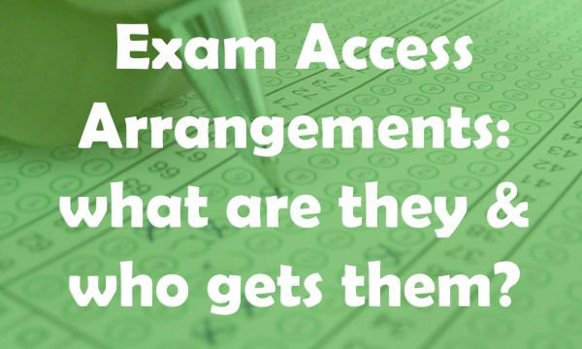

Access Arrangements are pre-examination adjustments for candidates based on evidence of need **and** normal way of working. Access Arrangements fall into two distinct categories: some arrangements are delegated to centres; others require prior JCQ awarding body approval.

**An Overview**

Access Arrangements allow candidates/learners with special educational needs, disabilities or temporary injuries to access the assessment without changing the demands of the assessment. For example, extra time, supervised rest breaks, readers, scribes and Braille question papers. In this way Awarding Bodies will comply with the duty of the Equality Act 2010 to make ‘reasonable adjustments’.

**Capel Manor College follows all exam regulations guidance as set out by the Joint Council for Qualifications (JCQ) and awarding bodies.**

Access Arrangements are only available to students with substantial long-term difficulties that are known to have an adverse effect on normal day-to-day activities in college. They are reasonable adjustments that are put in place to ensure that all students are given a fair opportunity to demonstrate their knowledge and skills in examinations, without being disadvantaged by any **learning, physical, sensory or psychological difficulty.**

Access Arrangements may vary between subjects because different subjects and methods of assessments may have different demands. Access Arrangements are agreed before an assessment, **based on ‘evidence of need’ and ‘normal way of working’.**

Decisions are based on:

* The college’s knowledge of the student’s needs and the support put in place in the classroom - their normal way of working.
* Findings of an assessor’s assessments.
* The requirements of the subjects they are taking.

**Points to note:**

The JCQ regulations are very clear that an independent assessment carried out without prior consultation with the college cannot be used to award Access Arrangements. However they may be used to build a picture of the student’s needs.

Access Arrangements are not meant to create an unfair advantage or compromise the integrity of an assessment.

If Capel Manor College fails to provide sufficient evidence, in line with JCQ regulations, then the student in question could have marks deducted due to their unfair advantage, and may jeopardise the college status as an approved examination centre.

For some students supervised rest breaks may be a suitable alternative to extra time, as guided by the JCQ, and as appropriate.

Exam anxiety is not sufficient reason for access arrangements.

A diagnosis of dyslexia will **not**mean automatic Exam Access Arrangements.  
  
‘**Use it or lose it!’**

Capel Manor College monitors how students are using their AA’s (e.g. extra time). Without this evidence of AA’s being used, the student could lose their AA’s in subjects. Where a student has AA in place they are encouraged to use it!

Who to contact:

If you believe you may be entitled to Access Arrangements, inform your subject teacher, who may then be able to refer you for assessment, subject to sufficient evidence.

Contact your previous school’s SENCO or Exams Officer, to provide you with the following documentation in relation to your Access Arrangements:   
- Form 8  
- JCQ approval  
- Certificate of assessor’s qualification   
  
It would be advisable to contact the school as soon as possible, so they can send us the information in due time, so as not to delay the application process.

You may wish to ask them to scan and email these documents directly to us at [accessarrangements@capel.ac.uk](mailto:accessarrangements@capel.ac.uk); or, send copies of the above documents to Capel Manor College, Bullsmoor Lane, Enfield, Middlesex, EN1 4RQ, FAO The Access Arrangements Team.

Student Support Services are on hand to provide information, advice and guidance on practical matters including SEN & Disability support.

Please discuss with your tutor if you feel you need learning support or alternatively you can self refer by emailing: learningsupport@capel.ac.uk