Annual Review Information for learners with an **E**ducation and **H**ealth **C**are **P**lan.

**Purpose:**

Learners with an Education and Health Care Plan (EHCP) are required by the SENDCOP (Send Code of Practice) to have their EHCP reviewed annually. This is to ensure the outcomes and support remains relevant and is a true reflection of where the learner is now.

Prior to a meeting taking place to review the plan the provision, Capel Manor College, must provide a report on the learner **describing their progress, engagement, attendance, ongoing difficulties and potential options for the next academic year. The provision must also look at the outcomes as stated in their plan**. These can be found on a learner’s one-page profile on promonitor and should **be incorporated into SMART targets set by tutors throughout the academic year**. This the enables us, at the Annual Review, to answer whether the outcomes have been:

* Met
* Not met
* Ongoing

The report needs to be completed by all members of staff that work with the learner to ensure we have a well-rounded picture of how the learner has progressed, what support they still require or whether they require more support than they have received.

These reports have to be sent out two weeks prior to the meeting date so it is vitally important that these are completed in a timely manner in order for our Learning Support Coordinators to be able to arrange the meetings.

The report document can be found on the learner’s promonitor page in the student meetings area entitled Annual Review meeting. These have all already been pre-populated, please do not create your own AR meeting. Please write your report in the relevant section only and start the report with ROLE - (Your name). Please include comments on the outcomes in your report as this will be the area of focus in the Annual Review meeting.

Your reports must be informative and give a good overview of the student. You should not include personal opinion only factual statements and observations. They should link to the student’s outcomes as stated in section E of the EHCP and can also be found in their one page profile under Additional Learning Support in promonitor.

**Where to find AR meeting om PROMONITOR:**

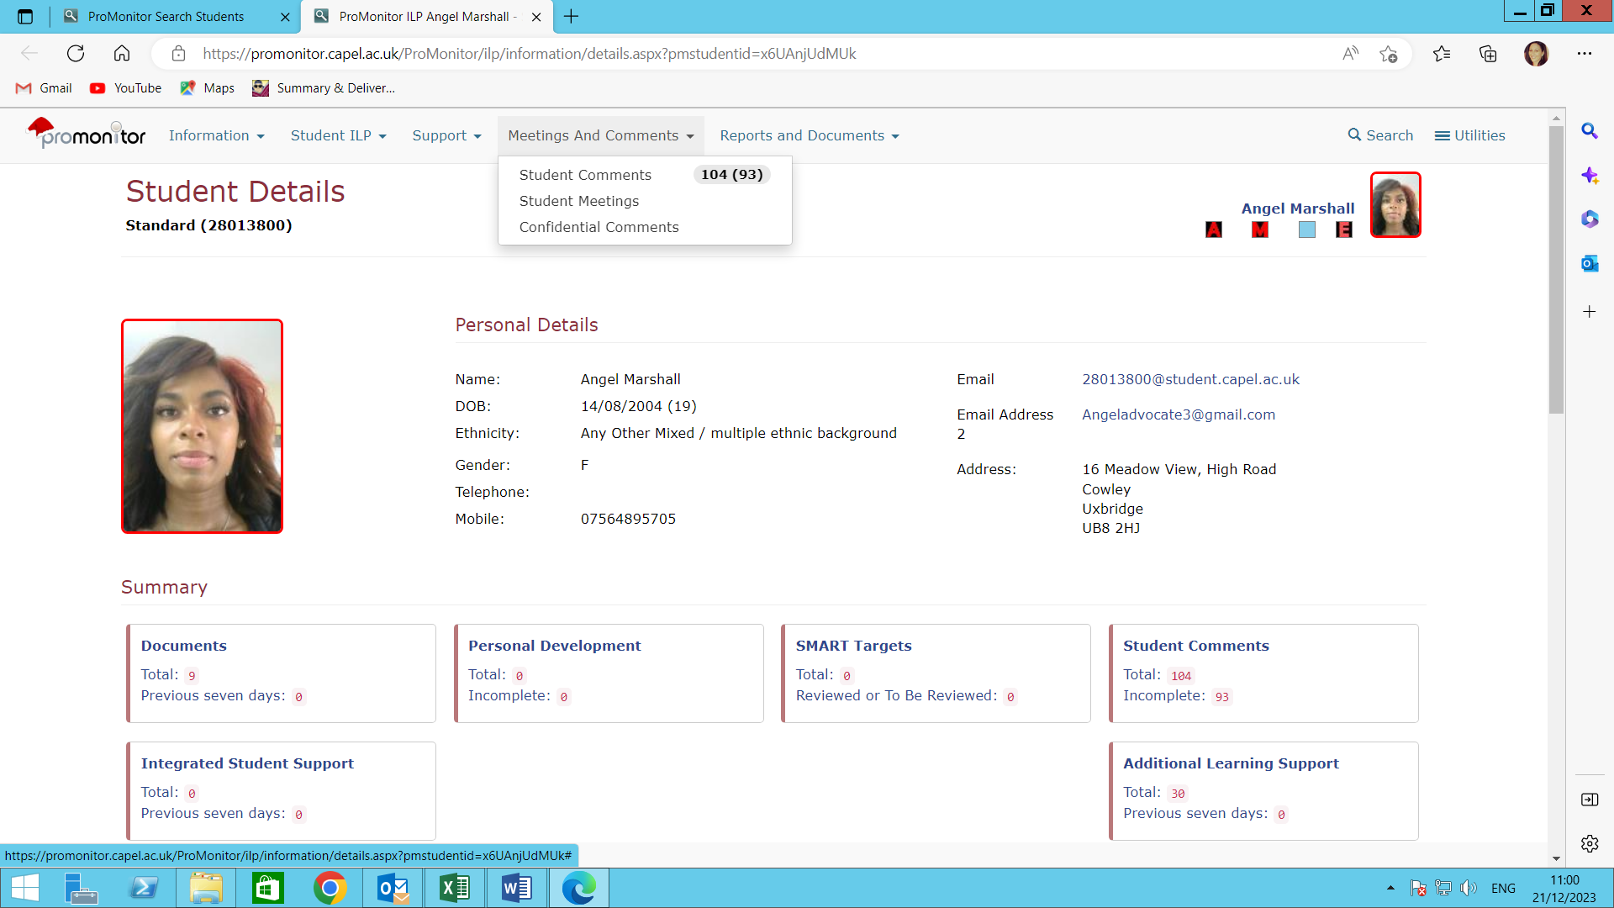

Click meetings and comments-choose student meetings

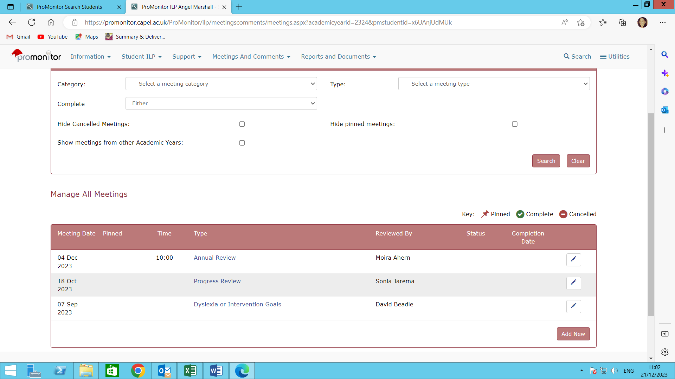

Click Annual review meeting

Write your report in the relevant Staff section.

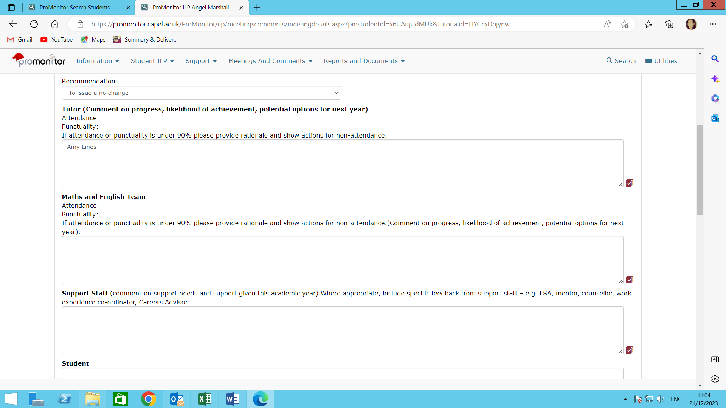

These sections will be completed by Learning Support Coordinators after the Annual Review meeting . Tutors should comment on the outcomes in the ‘Recommendations of any changes to support needs box as this box contains the students EHCP OUTCOMES.

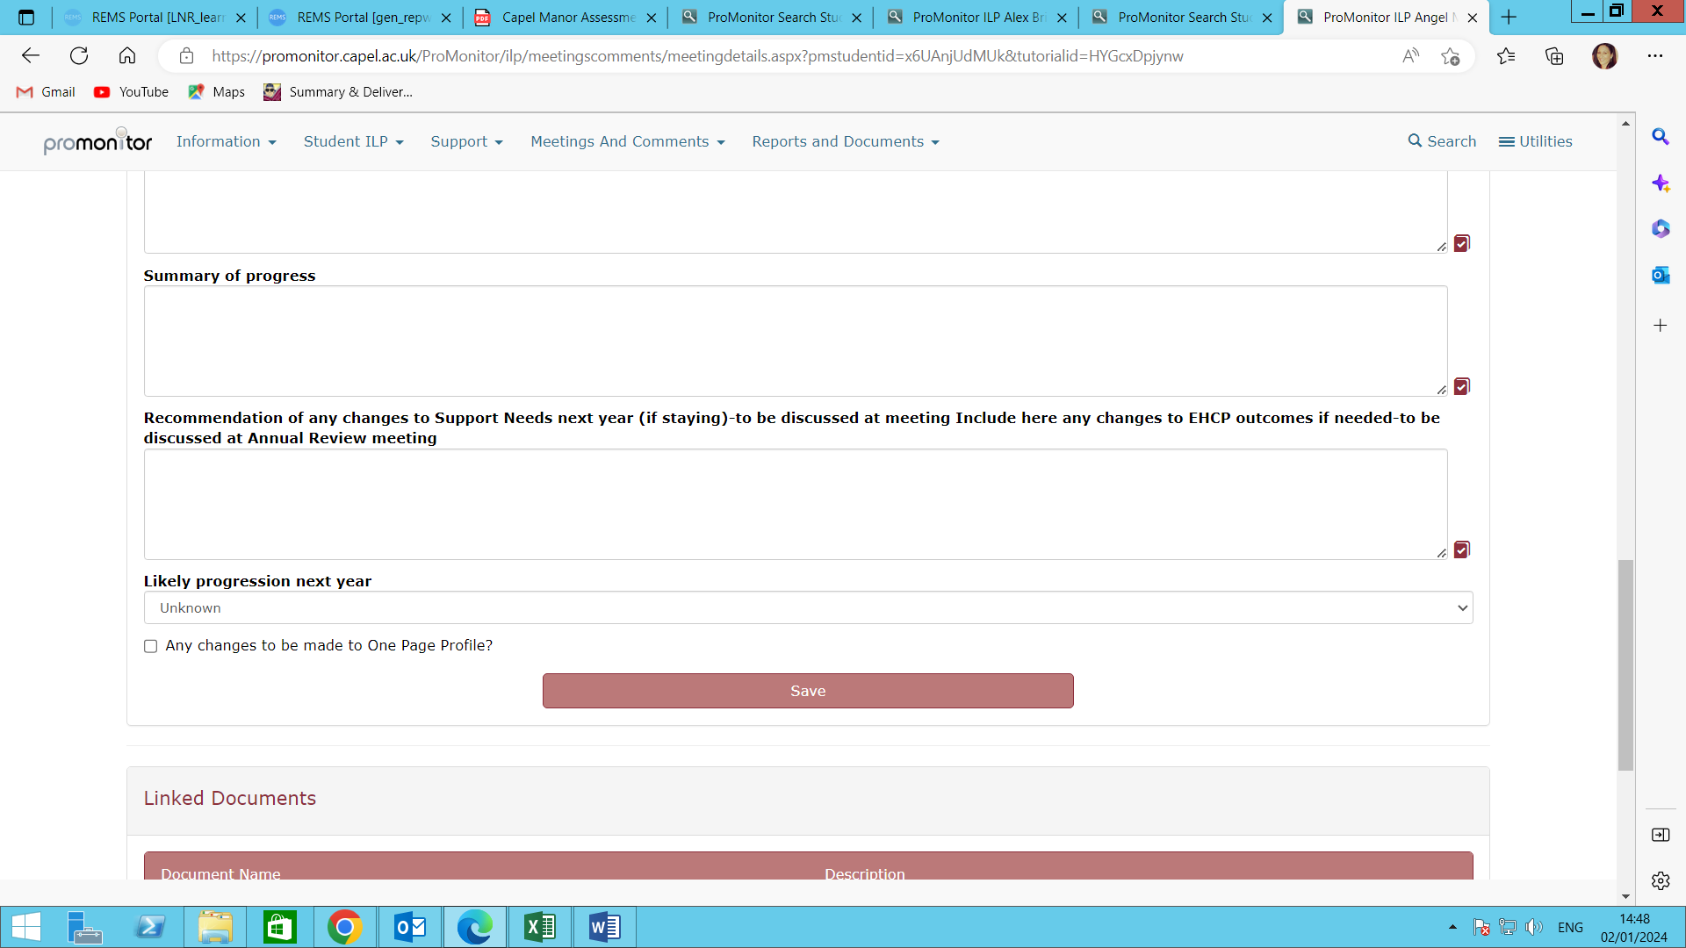

Please read the ‘Good example of an Annual Review report’ and the ‘bad example ‘ to understand the information Learning Support Coordinators and Local Authorities require and what is not an acceptable report.

If you have any questions on this process or require any support with your reports please do contact your campus Learning Support Coordinator as listed below.

[Precious.day@capel.ac.uk](mailto:Precious.day@capel.ac.uk) All courses for **Mottingham**

[Andrew.blake@capel.ac.uk](mailto:Andrew.blake@capel.ac.uk) All courses for **Crystal Palace**

[Jodie.Wheeler@capel.ac.uk](mailto:Jodie.Wheeler@capel.ac.uk) All courses for **Gunnersbury Park**

[Joanne.nicolaysen@capel.ac.uk](mailto:Joanne.nicolaysen@capel.ac.uk) All Animal Care courses for **ENFIELD**

[Jo.lam@capel.ac.uk](mailto:Jo.lam@capel.ac.uk) All other courses for **ENFIELD**