# **Study Skills Workbook**

## Introduction

Information is retained and recalled if:

* It is revisited in short bursts
* It is reviewed regularly
* It is linked to other information
* It involves more than one sense
* It uses both left and right sides of the brain
* It is relevant to you
* It is remembered by using one of the revision techniques on the following page.

What strategies work best for me? There are many different forms of revision and different strategies you can use. Everyone is different and everyone learns and revises in slightly different ways, but there are a few clear principles:

1. Reading is not revising – if you are not processing and using the information in some way, it is unlikely you will remember it.
2. You must test your skills and understanding so you can see how much you are remembering (use past exam papers)
3. Exam papers and questions are really important so you understand the content and structure of the exam Look at the techniques on the following page which you will have seen and heard about in your Study Skills session.

### TASK: Learning Strategies

At the start of this session, we did a questionnaire about learning styles. Which three strategies do you think would be the best for you?

What is it about them you might find effective?

## Revision techniques

Condensed notes Learning Posters Book of Facts

Mind maps Summary Tables/Grids Diagrams/drawnings

Flow Charts Prompt Cards Self Testing

Spider Diagrams Peer Teaching

### TASK: Using Index cards

Index cards are used to condense large pieces of text in to smaller chunks of information and finally in to a diagram, please see below for an example.

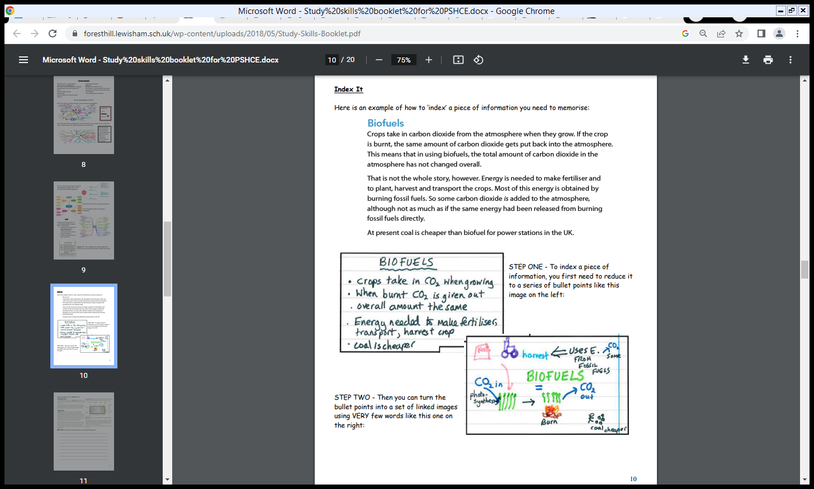



1. Please Choose a topic from the table on the page below. And break this down in to the main points.

• ------------------------------------------------------------------------------------------------

• ------------------------------------------------------------------------------------------------

• ------------------------------------------------------------------------------------------------

• ------------------------------------------------------------------------------------------------

• ------------------------------------------------------------------------------------------------

• ------------------------------------------------------------------------------------------------

• ------------------------------------------------------------------------------------------------

• ------------------------------------------------------------------------------------------------

• -----------------------------------------------------------------------------------------------

|  |  |
| --- | --- |
| **Story of Dolly**  The Clone Cloning is the production of an exact copy of a cell, any other living part, or a complete organism. Cloning of an animal was successfully performed for the first time by Ian Wilmut and his colleagues at the Roslin Institute in Edinburgh, Scotland. They successfully cloned a sheep named Dolly. Dolly was born on 5th July 1996 and was the first mammal to be cloned.  During the process of cloning Dolly, a cell was collected from the mammary gland of a female Finn Dorsett sheep. Simultaneously, an egg was obtained from a Scottish blackface ewe. The nucleus was removed from the egg. Then, the nucleus of the mammary gland cell from the Finn Dorsett sheep was inserted into the egg of the Scottish blackface ewe whose nucleus had been removed. The egg thus produced was implanted into the Scottish blackface ewe. Development of this egg followed normally and finally Dolly was born. Though Dolly was given birth by the Scottish blackface ewe, it was found to be absolutely identical to the Finn Dorsett sheep from which the nucleus was taken. Since the nucleus from the egg of the Scottish blackface ewe was removed, Dolly did not show any character of the Scottish blackface ewe. Dolly was a healthy clone of the Finn Dorsett sheep and produced several offspring of her own through normal sexual means. Unfortunately, Dolly died on 14th February 2003 due to a certain lung disease. Since Dolly, several attempts have been made to produce cloned mammals. However, many die before birth or die soon after birth. The cloned animals are many-a-times found to be born with severe abnormalities. | ***Plant Taxonomy***  Species are grouped into genera. A genus is a group of species thought to have a fairly recent common ancestor. Genera are grouped into families. Some of are very natural, while others are more mixed. Families are grouped into orders. Orders are grouped into classes. Classes are grouped into divisions or phyla. The highest level of classifications is that of the kingdom.3 There are many objectives of plant taxonomy in which the collection of plants, their studies in the herbarium (scientific names, identification and characteristics of plants) is the first objective of plant taxonomy, and the second objective is to give a method of diagnosis of plants, by the help of available fundamental data and pictorial matter etc and the last objective of plant taxonomy is to preparation of phylogenetic system of …show more content…  Early system of classification was mostly Artificials.6 It is based on less variable character and they do not reflect the relation present among the plants.7 Theophrastus (370-285 B.C.) is the father of botany. He sorted all plants on the basis of form and texture. He acknowledged trees, shrubs, undershrubs and herbs, and compare between annual, biennial and perennial plants. Dioscorides(60 A.D.) was a physician. His book De Materia Medica enclosed information on roots, stems, leaves and flowers of medicinal plants. Albertus Magnus (1193-1280 A.D.) acknowledged differences in stems of dicots and monocots and also compare between leafy and non-leafy |
| **Floral Design**  A floral arrangement is made whenever selected flowers and foliages are placed into a container according to a plan. Flowers casually placed in a container are attractive because of their beautiful color and shape, but the same flowers are even more appealing when arranged in a stylish way. Design is the selecting and arranging of objects and deals with the form of their composition. Good floral design is the result of a well thought-out plan, with two aims in mind – order and beauty. Good design doesn’t just happen, there must be a relationship between all of its component parts – a feeling of security, naturalness, balance and simplicity. The floral arranger must have a basic idea, a mental picture of what they wish to create, where the arrangement will be placed, and the function it will serve. Most floral arrangements are made for a particular purpose or place. The arrangement should be suitable for its intended use. A good floral arrangement should be expressive of a theme or idea and of one’s own personality. In order to arrange flowers in such a manner it is necessary to become acquainted with all the elements of good design. The elements of design are color, light, space, line, form, pattern, texture, and size. The principles of design are balance, dominance, contrast, rhythm, proportion, and scale. These same elements and principles of design apply to every art form. Some attributes of design are beauty, harmony and expression. | |

1. Place this information in to an index card below, be sure to use colour and arrows and doodles/diagrams in your card.

### TASK: Story it

Create a story to remember key words or points. For example, you can create a story to remember the 7 different nutrients. (Below is just an example, try to come up with your own)

Carbohydrates You reached school and noticed the sign had been changed to Carbo High.

Fat In the basketball area you notice several big Fat sheep.

Protein The sheep were Playing with the ball because they had been eating their protein,

Fibre When your Friend ran up and grabbed it. He ran off to the

Water Water fountain where the water had turned into

Minerals Melon juice full of minerals which started running over and spilling

Vitamins Staining all the sheep a bright shade of Violet